**Analytics on AWS**

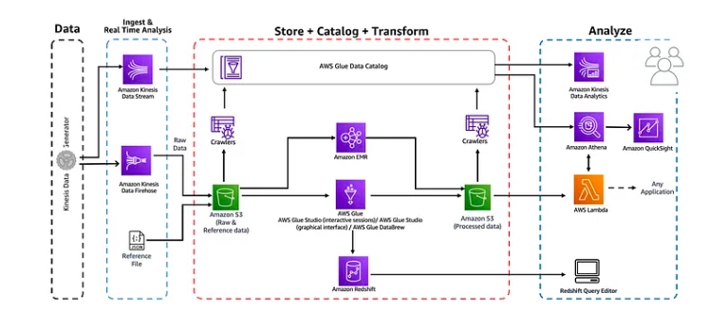

Amazon Athena and AWS Glue have emerged as powerful tools for seamlessly querying and processing data stored in Amazon S3. Harness the potential of Athena and Glue to analyse data, create databases, and execute SQL queries effortlessly.

**XXXXXXXXXXXXXXXXXXXXXXXXXXXXXXXXXXXXXXX**

[**Implement:**](https://catalog.us-east-1.prod.workshops.aws/workshops/44c91c21-a6a4-4b56-bd95-56bd443aa449/en-US)

The workshop explores the capabilities of **Amazon Athena**, a serverless query service, and **AWS Glue**, a fully-managed ETL service.  
In this workshop, we will go over a sequence of modules, covering various aspects of building an analytics platform on AWS. You will learn to **ingest**, **store**, **transform** and **consume** data using several analytics services such as **AWS Glue**, **Amazon Athena**, **Amazon Kinesis**, **Amazon QuickSight** as well as **AWS Lambda**.  
Note: We need AWS account with **AdminstratorAccess**and thislab should be executed in **us-east-1** region

A more detailed representation of the design is presented in the architecture below -



**XXXXXXXXXXXXXXXXXXXXXXXXXXXXXXXXXXXXXXX**

**Tasks:**

1. Ingest and Store  
   a) Navigate to S3 Console & Create a **new bucket** in us-east-1 region and add reference data.  
   b) Create a **Kinesis Firehose delivery stream** to ingest data & store in S3  
   c) **Generate Dummy data** — configure Kinesis Data Generator to produce fake data and ingest it into Kinesis Firehose.  
   d) Validate that data has arrived in S3.
2. Catalog Data  
   a) Create **IAM** Role  
   b) Create **glue crawlers**to discovery the schema of the newly ingested data in S3.  
   c) Verify **newly created tables in catalog**d) Query ingested data using **Amazon Athena**
3. Data transformation  
   Transform Data with AWS Glue Studio (interactive sessions)  
   a) Prepare **IAM Policies and Rules**.  
   b) Use **Jupyter Notebook in AWS Glue** for interactive ETL development.

4. Analyze with Athena

5. Visualize in Quicksight

6. Serve with Lambda

7. Cleanup

**XXXXXXXXXXXXXXXXXXXXXXXXXXXXXXXXXXXXXXX**

**Solution:**

**Task 1 👉: Ingest and Store**

Generate some dummy data in near real-time using Kinesis data generator utility, and deliver the data to Amazon S3 with Kinesis Firehose delivery stream. We will also copy some reference data directly into Amazon S3 bucket.

**a) Navigate to S3 Console & Create a new bucket in us-east-1 region and add reference data.**

Goto : S3 Console [Click me](https://s3.console.aws.amazon.com/s3/home?region=us-east-1) and click — **Create Bucket**Bucket Name : yourname-analytics-workshop-bucket  
Region : **US EAST (N. Virginia)**Optionally add Tags, e.g.: workshop: AnalyticsOnAWS  
Click **Create bucket**

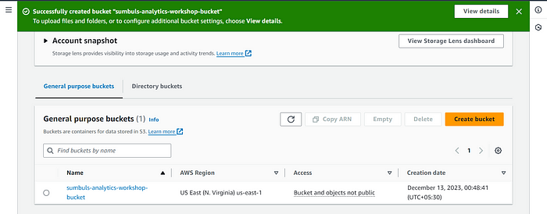

Adding reference data  
Open — yourname-analytics-workshop-bucket  
Click — **Create folder**New folder : data  
Click — **Save**

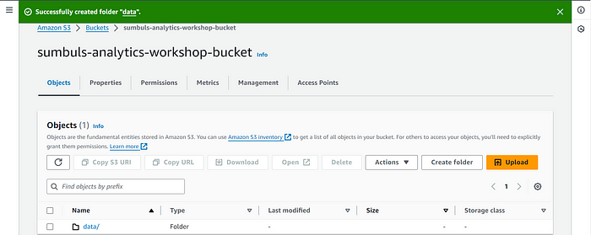

Open — **data**Click — **Create folder** (From inside the data folder)  
New folder : reference\_data  
Click — **Save**

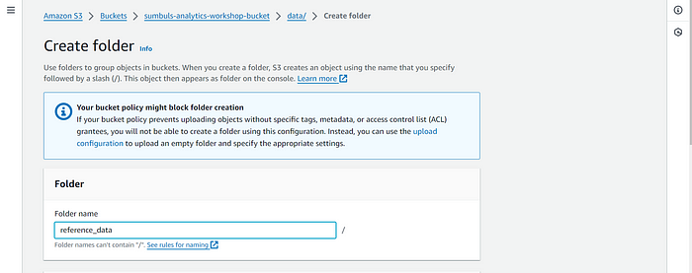

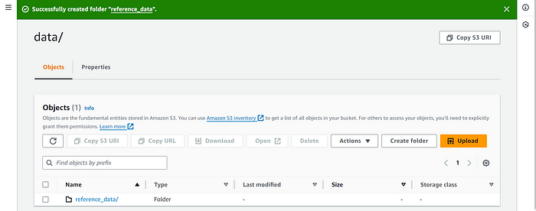

Open — **reference\_data**download this file locally : [tracks\_list.json](https://static.us-east-1.prod.workshops.aws/public/9b2d1982-fdcf-4207-ba26-71a458796115/static/data/tracks_list.json" \t "_blank)  
In the S3 Console — Click — Upload  
Click **Add files** & upload the **tracks\_list.json** file here  
Click **Upload** (bottom left)

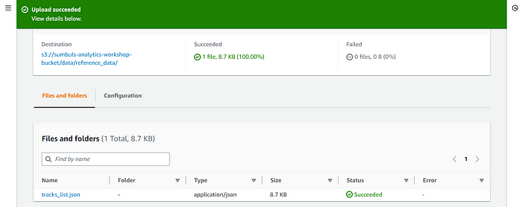

**XXXXXXXXXXXXXXXXXXX**

**b) Create a Kinesis Firehose delivery stream to ingest data & store in S3**Goto: Kinesis Firehose Console [Click me](https://console.aws.amazon.com/firehose/home?region=us-east-1). Click **Create delivery stream**

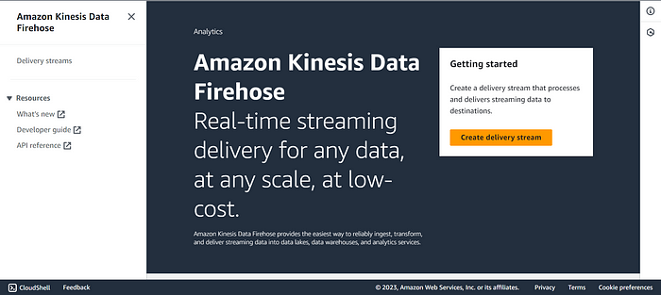

Step 1: Choose source and destination  
Source: **Direct PUT**Destination: **Amazon S3**

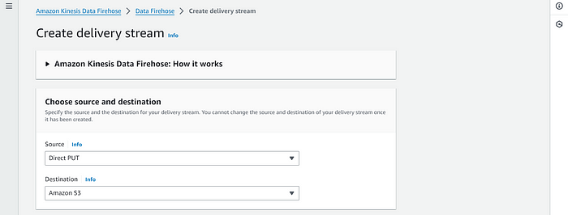

Step 2: Delivery stream name  
Delivery stream name: analytics-workshop-stream

Step 3: Transform and convert records  
Transform source records with AWS Lambda: **Disabled**  
RecConvert record format: **Disabled**

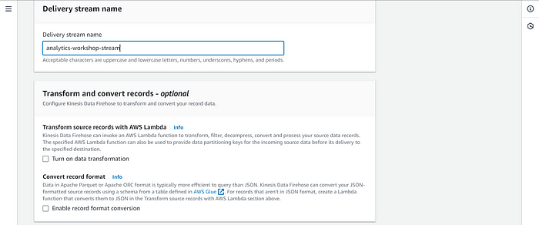

Step 4: Destination settings  
S3 bucket: **yourname-analytics-workshop-bucket**Dynamic partitioning: **Not Enabled**S3 bucket prefix: data/raw/  
(**Note:** the slash **/** after **raw** is important. If you miss it Firehose will copy the data into an undesired location)

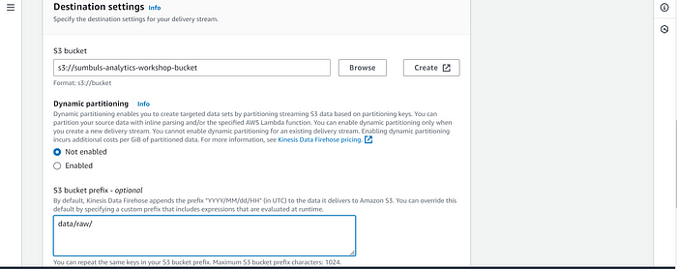

S3 bucket error output prefix: Leave BlankExpand **Buffer hints, compression and encryption:**Buffer size: **1 MiB**Buffer interval: **60 seconds**Compression for data records: **Not Enabled**Encryption for data records: **Not Enabled**

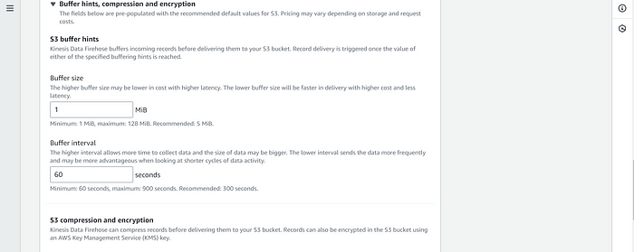

Step 5: Advanced settings  
Server-side encryption: **unchecked**Amazon Cloudwatch error logging: **Enabled**Permissions: **Create or update IAM role KinesisFirehoseServiceRole-xxxx**

Optionally add Tags, e.g.: Key: workshop Value: AnalyticsOnAWS

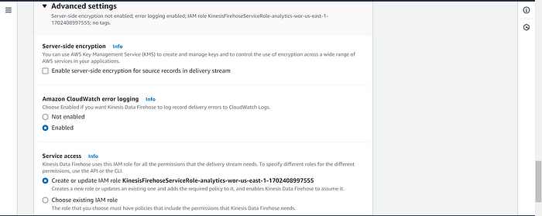

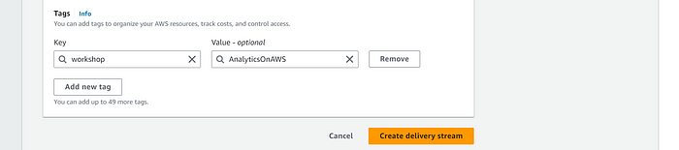

Step 6: Review  
Review the configuration & make sure its as mentioned above and click — **Create delivery stream.**

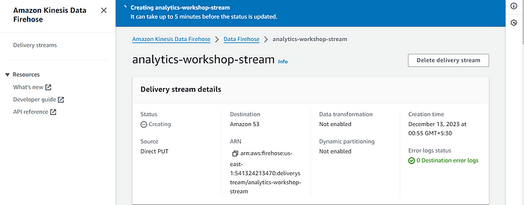

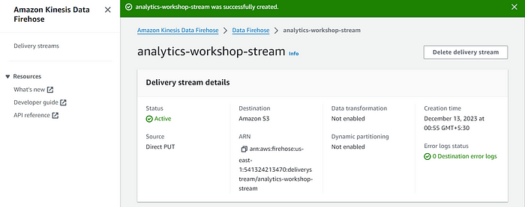

**XXXXXXXXXXXXXXXXXXXXX**

**c) Generate Dummy data — configure Kinesis Data Generator to produce fake data and ingest it into Kinesis Firehose**

**Configure Amazon Cognito** for Kinesis Data Generator — In this step we will launch a cloud formation stack that will configure Cognito. This cloudformation scripts launches in **N.Virginia region**

Goto: <https://console.aws.amazon.com/cloudformation/home?region=us-east-1#/stacks/new?stackName=Kinesis-Data-Generator-Cognito-User&templateURL=https://aws-kdg-tools-us-east-1.s3.amazonaws.com/cognito-setup.json>

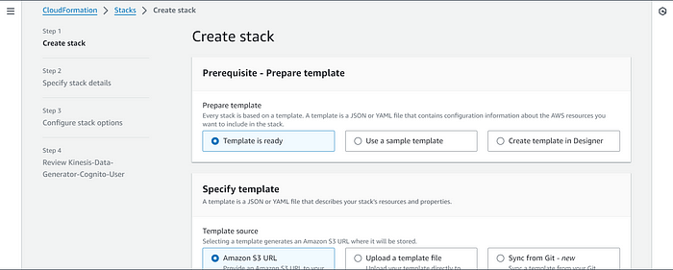

Click **Next.**Specify Details:  
Username: **admin**Password: **choose an alphanumeric password**Click **Next**

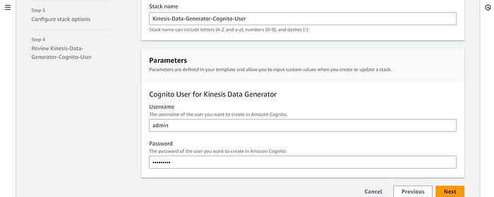

Options:  
Optionally add Tags, e.g.: **workshop**: **AnalyticsOnAWS**Click **Next**

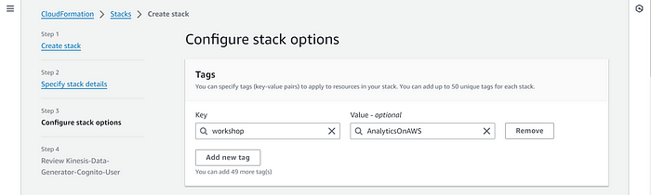

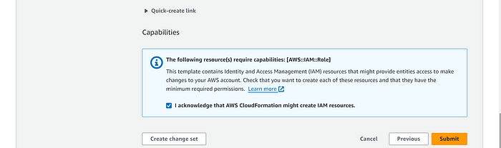

Review:  
I acknowledge that AWS CloudFormation might create IAM resources: **Check.**Click **Create stack.**

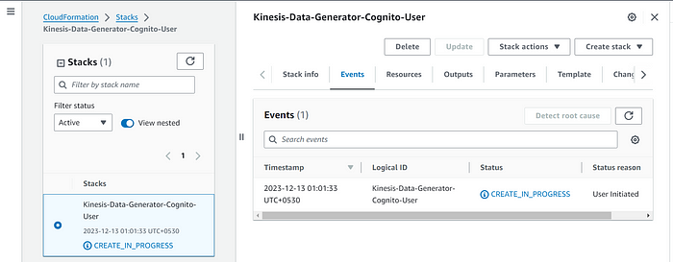

Wait till the stack status changes to **Create\_Complete**

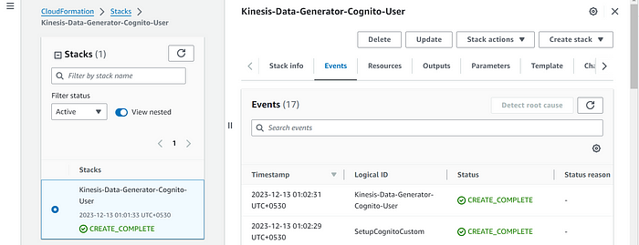

Select the **Kinesis-Data-Generator-Cognito-User** stack

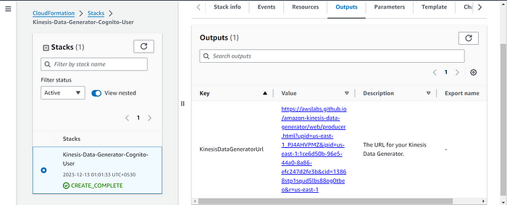

GoTo outputs tab: click on the link that says: **KinesisDataGeneratorUrl** — This will open your Kinesis Data Generator tool.  
On Amazon Kinesis Data Generator homepage.  
**Login** with your username & password from previous step.

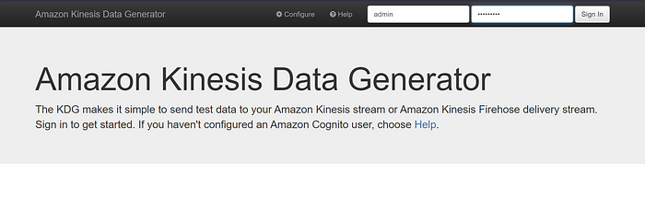

* Stream/delivery stream: **analytics-workshop-stream**
* Records per second: **2000**

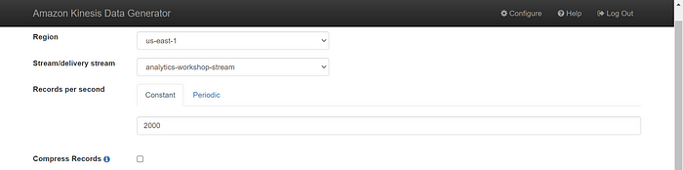

* Record template (Template 1): In the **big text area**, insert the following json template:

{  
 "uuid": "{{random.uuid}}",  
 "device\_ts": "{{date.utc("YYYY-MM-DD HH:mm:ss.SSS")}}",  
 "device\_id": {{random.number(50)}},  
 "device\_temp": {{random.weightedArrayElement(  
 {"weights":[0.30, 0.30, 0.20, 0.20],"data":[32, 34, 28, 40]}  
 )}},  
 "track\_id": {{random.number(30)}},   
 "activity\_type": {{random.weightedArrayElement(  
 {  
 "weights": [0.1, 0.2, 0.2, 0.3, 0.2],  
 "data": ["\"Running\"", "\"Working\"", "\"Walking\"", "\"Traveling\"", "\"Sitting\""]  
 }  
 )}}  
}

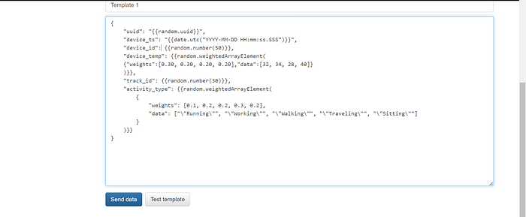

Click — **Send Data.**Once the tool sends ~10,000 messages, you can click on — **Stop sending data to Kinesis**

**XXXXXXXXXXXXXXXXXXXXX**

**d) Validate that data has arrived in S3**

After few moments go to the S3 console [Click me](https://s3.console.aws.amazon.com/s3/home?region=us-east-1). Navigate to: **yourname-analytics-workshop-bucket > data**

There should be a folder called **raw** > Open it and keep navigating, you will notice that firehose has dumped the data in S3 using **yyyy/mm/dd/hh** partitioning.

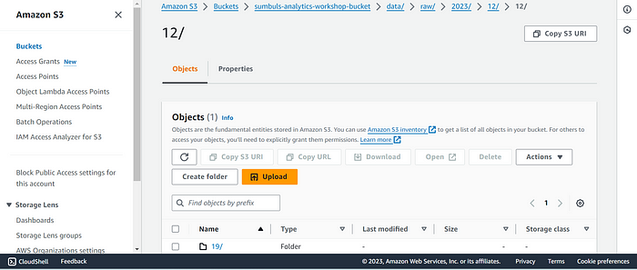

If you have received the dummy data in your S3 buckets, we are good to proceed to next step!

**XXXXXXXXXXXXXXXXXXXXXXXXXXXXXX**

**Task 2 👉: Catalog Data**

Here, we are going to register the datasets in the AWS Glue Data Catalog. We will automate the metadata capture with the help of Glue Crawlers.

Once the catalog entities are created, we will able to start querying the raw format of the data from Amazon Athena.

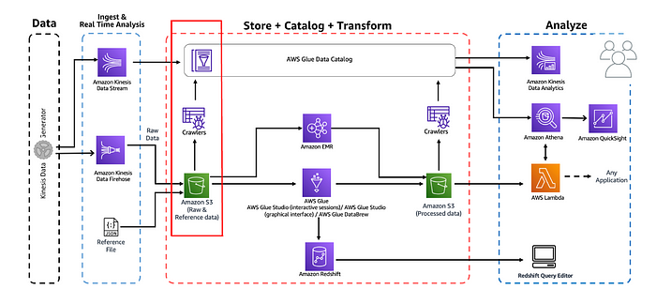

**a) Create IAM Role**

In this step we will navigate to the IAM Console and create a new AWS Glue service role. This allows AWS Glue to access the data stored in S3 and to create the necessary entities in the Glue Data Catalog. Go to: [Click me](https://console.aws.amazon.com/iam/home?region=us-east-1#/roles)

Click **Create role**Choose the service that will use this role: **Glue and c**lick **Next**

* Search for **AmazonS3FullAccess**Select the entry’s **checkbox**
* Search for **AWSGlueServiceRole**Select the entry’s **checkbox**

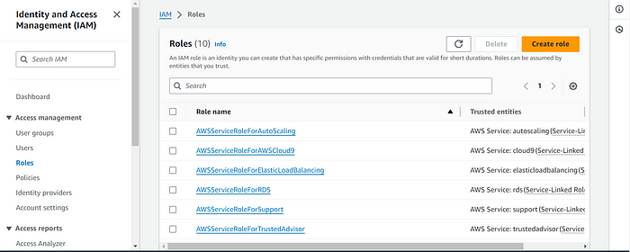

Click **Next**

Role name: AnalyticsworkshopGlueRole  
Make sure that only two policies attached to this role (**AmazonS3FullAccess**, **AWSGlueServiceRole**)  
Optionally add Tags, e.g.: **workshop**: **AnalyticsOnAWS**

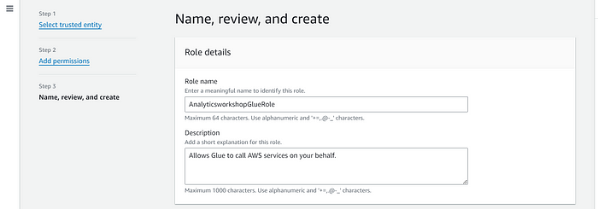

Click **Create role**

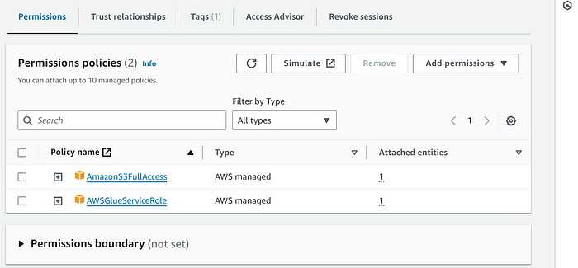

**b) Create glue crawlers to discovery the schema of the newly ingested data in S3.**Goto: [Click me](https://console.aws.amazon.com/glue/home?region=us-east-1). On the left panel, click on **Crawlers,**Click on **Create crawler.**

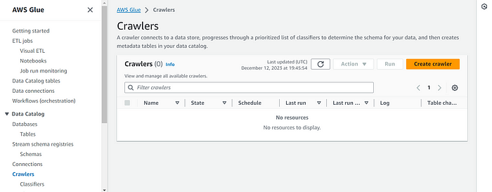

Enter Crawler info and Click **Next**

* Crawler name: AnalyticsworkshopCrawler
* Optionally add Tags, e.g.: **workshop**: **AnalyticsOnAWS**

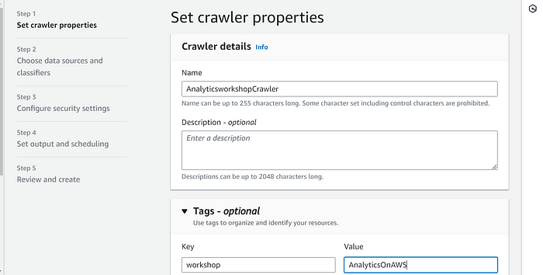

Click **Add a data source**

Choose a **Data source**: **S3**Leave **Network connection — optional** as-is  
Select **In this account** under **Location of S3 data**Include S3 path: s3://yourname-analytics-workshop-bucket/data/

Leave **Subsequent crawler runs** to default selection of **Crawl all sub-folders**Click **Add an S3 data source**Select recently added S3 data source under **Data Sources.**Click **Next**

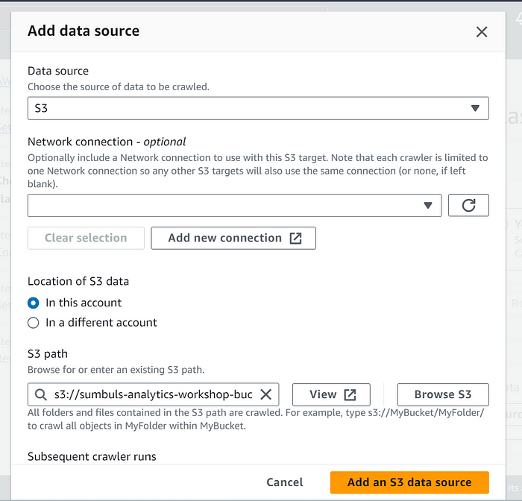

**IAM Role**. Under **Existing IAM role**, select AnalyticsworkshopGlueRole

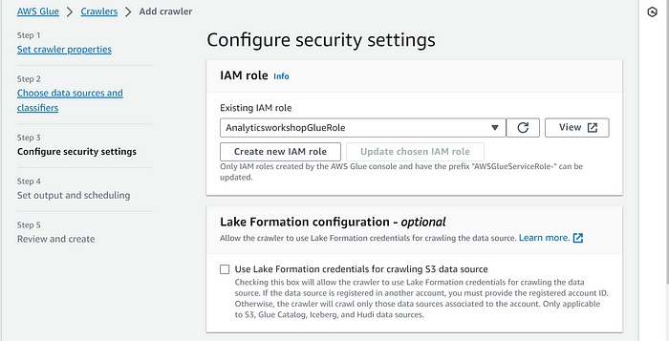

Output configuration:  
Click **Add database** to bring up a new window for creating a database.  
Database details Name: analyticsworkshopdb Click **Create database**

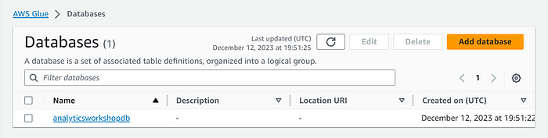

Closes the current window and returns to the previous window.  
Refresh by clicking the refresh icon to the right of the **Target database**Choose analyticsworkshopdb under **Target database**

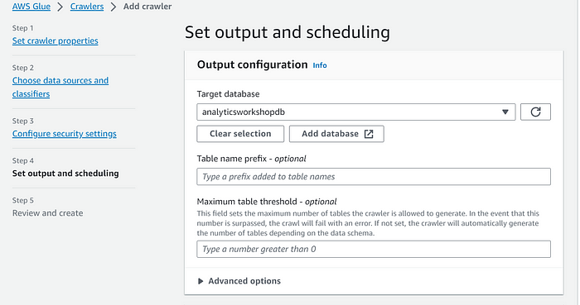

Under **Crawler schedule.**Frequency: **On demand.**Click **Next**

Review all settings under **Review and create.**Click **Create crawler**

You should see this message: **The following crawler is now created: “AnalyticsworkshopCrawler”.**Click **Run crawler** to run the crawler for the first time. Wait for few minutes

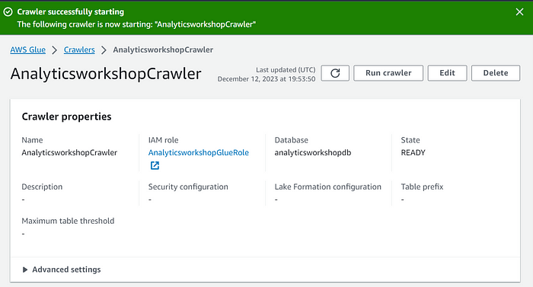

**c) Verify newly created tables in catalog**

Navigate to Glue Catalog [Click me](https://console.aws.amazon.com/glue/home?region=us-east-1#catalog:tab=databases) and explore the crawled data:  
Click **analyticsworkshopdb**Click **Tables in analyticsworkshopdb**Click **raw**

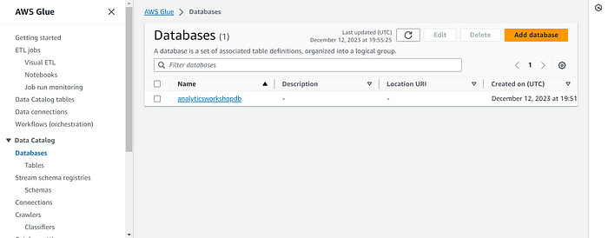

Look around and explore the **schema** for your dataset  
look for the averageRecordSize, recordCount, compressionType

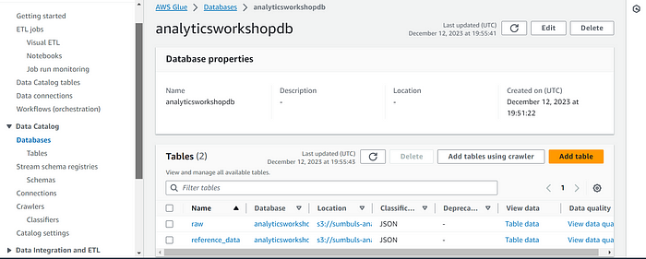

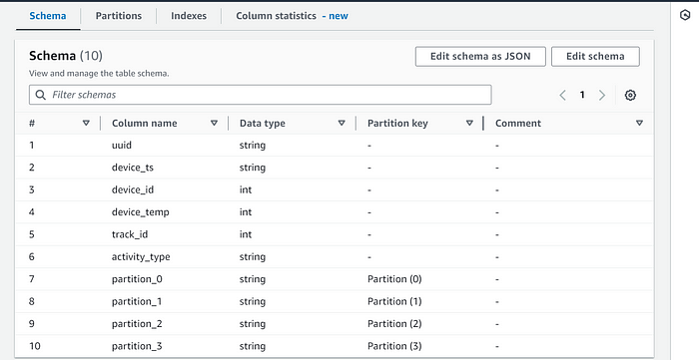

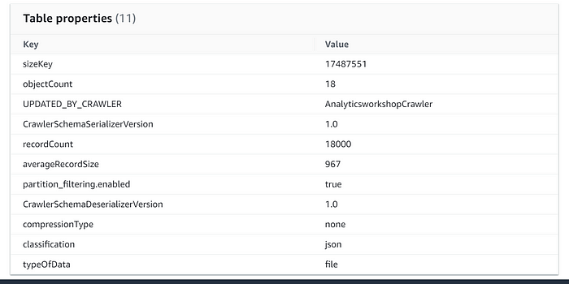

**d) Query ingested data using Amazon Athena**

Let’s query the newly ingested data using Amazon Athena. Goto: [Click me](https://us-east-1.console.aws.amazon.com/athena/home?region=us-east-1#query)

If necessary, click **Edit seetings** in the blue alert near the top of the Athena console.  
**Location of query result** Under **Query result location and encryption**: s3://yourname-analytics-workshop-bucket/query\_results/Click **Save**

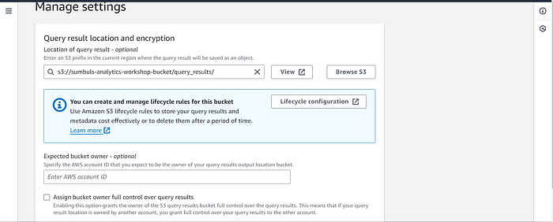

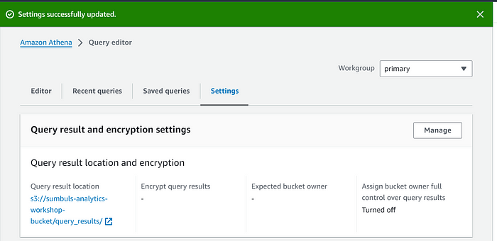

Click **Editor** tab  
On the left panel (**Database**) drop down , select **analyticsworkshopdb** > select table **raw**Click on **3 dots** (3 vertical dots) > Select **Preview Table.**Review the output.

In query editor, paste the following below query, and click **Run**.

SELECT activity\_type,  
 count(activity\_type)  
FROM raw  
GROUP BY activity\_type  
ORDER BY activity\_type

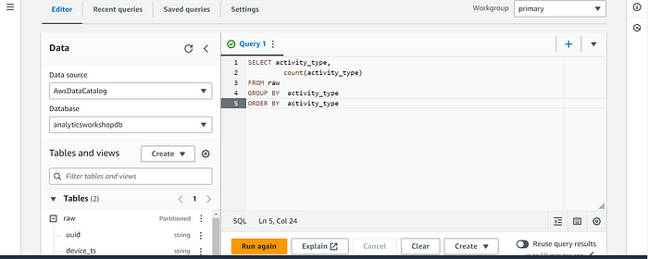

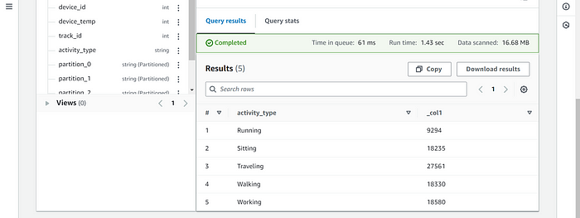

Now that we have cataloged the data, lets proceed to the next step of transforming the data using AWS Glue ETL!

**XXXXXXXXXXXXXXXXXXXX**

**Task 3 👉: Data transformation**Transform Data with AWS Glue Studio (interactive sessions)

a) Prepare IAM Policies and Rules.  
b) Use Jupyter Notebook in AWS Glue for interactive ETL development.

In this module, we are going to use AWS Glue interactive sessions to process the data and store back the results into a transformed layer back in S3. We will use Glue Studio and Jupyter notebooks powered by AWS Glue Interactive Sessions to work through the data transformation steps.

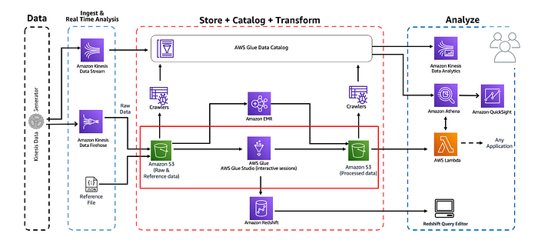

[**What is AWS Glue interactive sessions?**](https://catalog.us-east-1.prod.workshops.aws/workshops/44c91c21-a6a4-4b56-bd95-56bd443aa449/en-US/lab-guide/transform-glue-interactive-sessions#what-is-aws-glue-interactive-sessions)

Interactive sessions allows you to interactively develop AWS Glue processes, run and test each step, and view the results. If you prefer a code-based experience and want to interactively author data integration jobs, interactive sessions is recommended.

**a) Prepare IAM Policies and Rules.**  
Navigate to IAM console and create the necessary IAM policies and role to work with **AWS Glue Studio Jupyter notebooks** and interactive sessions.

Let’s start by creating an **IAM policy** for the AWS Glue notebook role.  
Go to: [Click me](https://us-east-1.console.aws.amazon.com/iamv2/home?region=us-east-1#/policies). Click **Policies** from menu panel on the left. Click **Create policy.**Click on **JSON** tab.

Replace default text in policy editor window with the following policy statemenent.

{  
 "Version": "2012-10-17",  
 "Statement": [  
 {  
 "Effect": "Allow",  
 "Action": "iam:PassRole",  
 "Resource":"arn:aws:iam::<AWS account ID>:role/Analyticsworkshop-GlueISRole"  
 }  
 ]  
}

**Note:**Analyticsworkshop-GlueISRole is the role that we create for the **AWS Glue Studio Jupyter notebook**in next step.  
**Alert:** Replace with your **AWS account ID** in the copied policy statement.

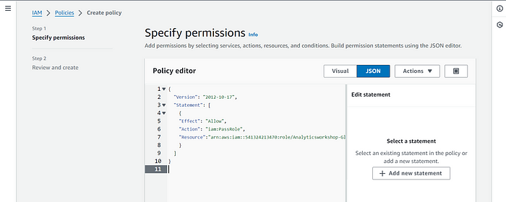

Click **Next: Tags a**dd Tags, e.g.: **workshop**: **AnalyticsOnAWS**Click **Next: Review**

* Policy Name: AWSGlueInteractiveSessionPassRolePolicy
* Optionally write description for the policy: The policy allows AWS Glue notebook role to pass to interactive sessions so that the same role can be used in both places
* Click **Create policy**

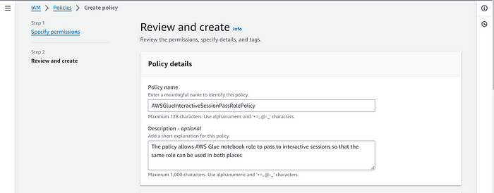

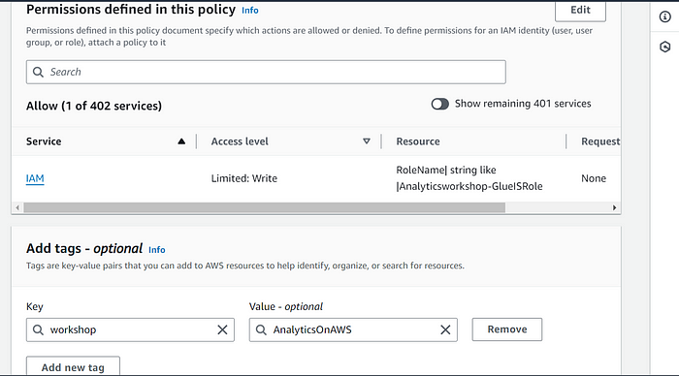

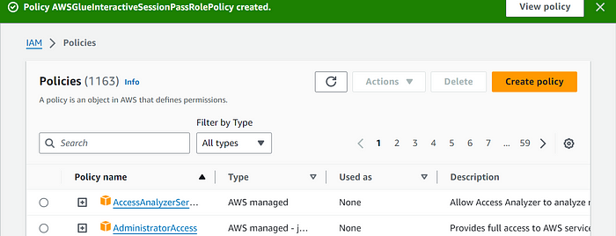

Next, create an **IAM role for AWS Glue notebook.**Goto: [Click me](https://us-east-1.console.aws.amazon.com/iamv2/home#/roles)

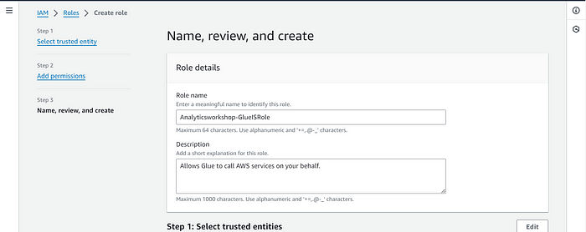

Click **Roles** from menu panel on the left. Click **Create role.**Choose the service that will use this role: **Glue** under **Use Case** and **Use cases for other AWS services**and Click **Next:**

Search for following policies and select the checkbox against them, then Click **Next**:

* AWSGlueServiceRole
* AwsGlueSessionUserRestrictedNotebookPolicy
* AWSGlueInteractiveSessionPassRolePolicy
* AmazonS3FullAccess

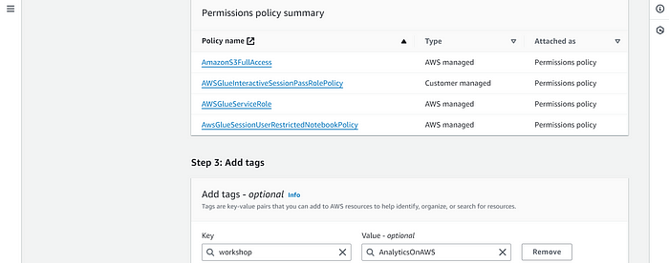

Role name: Analyticsworkshop-GlueISRole

Make sure only four policies are attached to this role (**AWSGlueServiceRole**, **AwsGlueSessionUserRestrictedNotebookPolicy**, **AWSGlueInteractiveSessionPassRolePolicy**, **AmazonS3FullAccess**)

Optionally add Tags, e.g.: **workshop**: **AnalyticsOnAWS**Click **Create role**

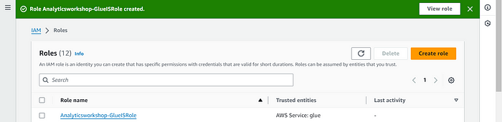

Note: For on getting started with notebooks in AWS Glue Studio, refer to [Getting started with notebooks in AWS Glue Studio](https://docs.aws.amazon.com/glue/latest/ug/notebook-getting-started.html).

**b) Use Jupyter Notebook in AWS Glue for interactive ETL development**

In this step you will be creating an **AWS Glue job with Jupyter Notebook** to interactively develop **Glue ETL scripts** using PySpark.

Download and save this file locally on your laptop : [analytics-workshop-glueis-notebook.ipynb](https://static.us-east-1.prod.workshops.aws/public/9b2d1982-fdcf-4207-ba26-71a458796115/static/notebooks/analytics-workshop-glueis-notebook.ipynb). Go to: Glue Studio jobs [Click me](https://us-east-1.console.aws.amazon.com/gluestudio/home?region=us-east-1#/jobs)

* Select **Jupyter Notebook** option
* Select **Upload and edit an existing notebook.**Click **Choose file**
* Browse and upload **analytics-workshop-glueis-notebook.ipynb** which you downloaded earlier. Click **Create.**

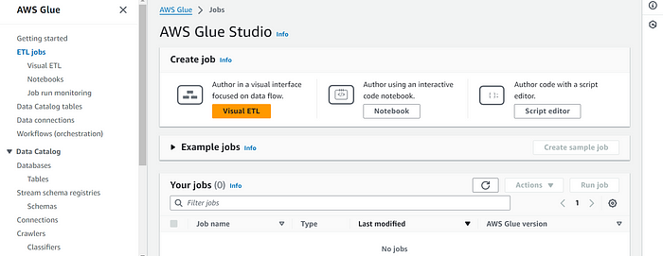

* Under **Notebook setup** and **Initial configuration**
* Job name: AnalyticsOnAWS-GlueIS
* IAM role Analyticsworkshop-GlueISRole
* Leave **Kernel** to default as Spark
* Click **Start notebook**

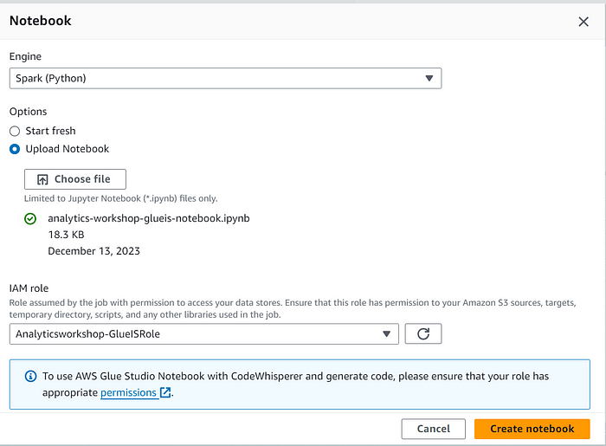

**Once the notebook is initialized, follow the instructions in the notebook**

Read and understand the instructions as they explain important Glue concepts.

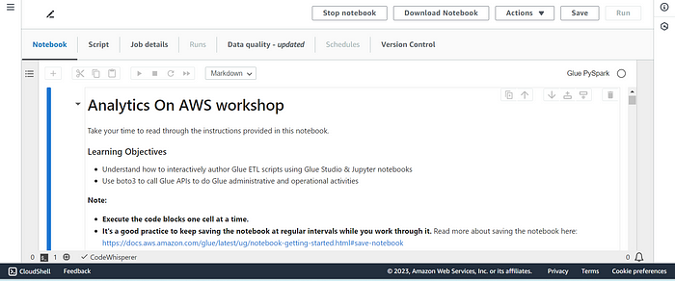

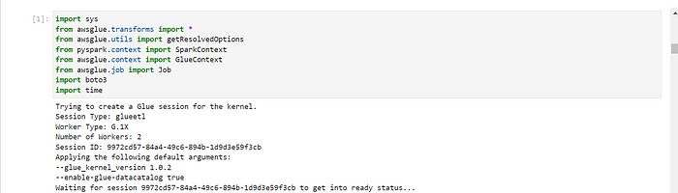

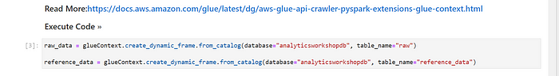

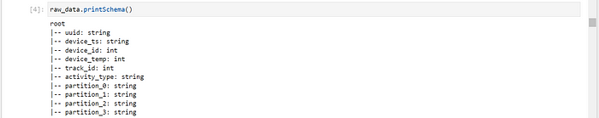

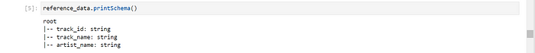

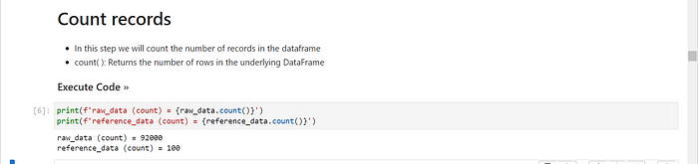

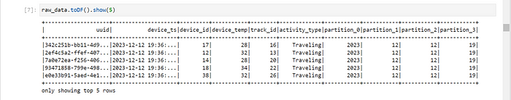

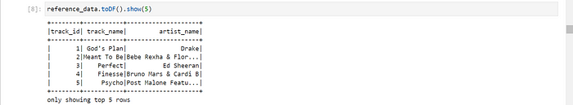

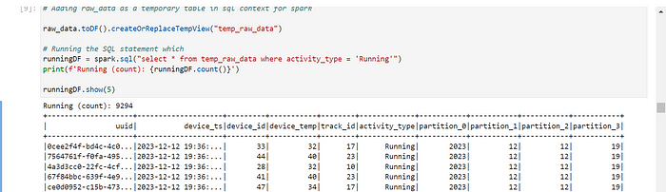

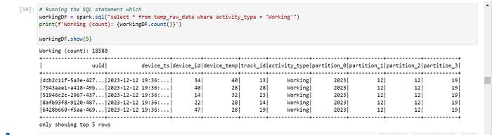

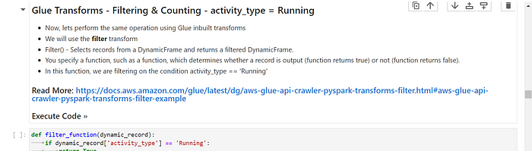

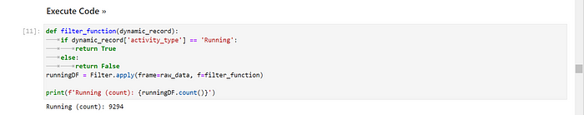

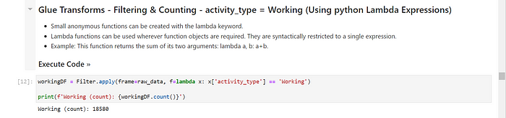

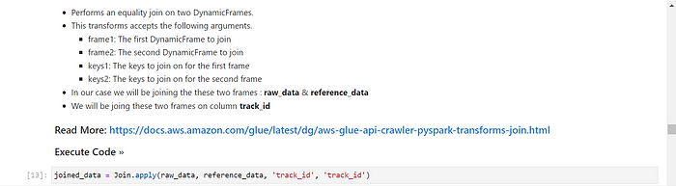

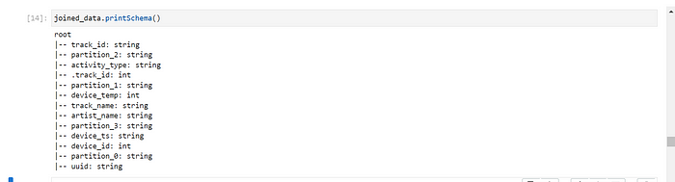

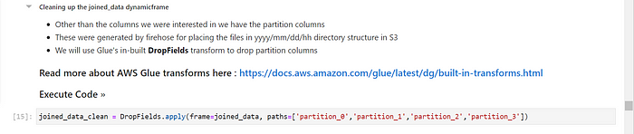

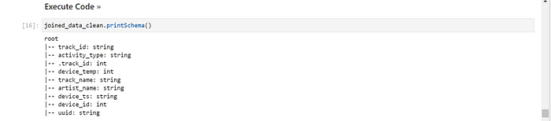

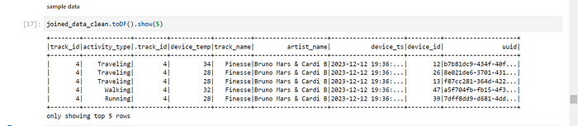

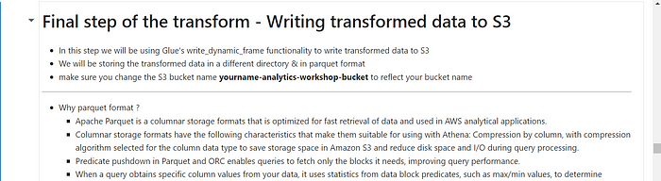

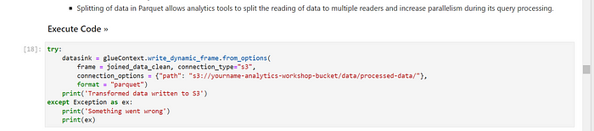

[**Validate — Transformed / Processed data has arrived in S3**](https://catalog.us-east-1.prod.workshops.aws/workshops/44c91c21-a6a4-4b56-bd95-56bd443aa449/en-US/lab-guide/transform-glue-interactive-sessions#validate-transformed-processed-data-has-arrived-in-s3)

Once the ETL script has ran successfully, return to the console: [Click me](https://s3.console.aws.amazon.com/s3/home?region=us-east-1)

Click — **yourname-analytics-workshop-bucket > data**

Open the **processed-data** folder: Ensure that **.parquet** files have been created in this folder.

Now that we have transformed the data, we can query the data using **Amazon Athena**. We could also further transform/aggregate the data with AWS Glue or Amazon EMR.

**XXXXXXXXXXXXX**

**Task 4 👉: Analyze with Athena**

So far, we have stored a few data sets in Amazon S3, and cataloged them in **AWS Glue data catalog**. With **Amazon Athena**we will be able to explore the data using Standard **SQL** queries.

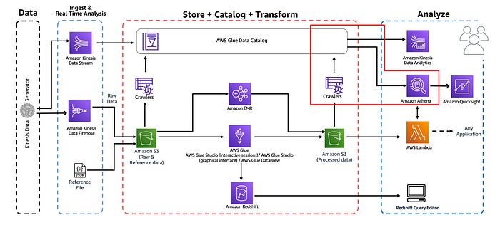

Login to the Amazon Athena Console. Goto: Athena Console [Click me](https://console.aws.amazon.com/athena/home?region=us-east-1#query)

If you see a notification requiring you to first create an S3 bucket to store the results of your queries, follow these steps:

* Go to the **S3 console** and create a bucket using your preferred name, e.g. **yourname-query-results**
* After creating the bucket, return to the Athena console and click **‘Settings’** on the top-right of the console.
* Enter the name of the bucket you have just created, ensuring you include a trailing slash: **s3://yourname-query-results/**
* Hit **Save**

As **Athena** uses the **AWS Glue catalog**for keeping track of data source, any **S3**backed table in **Glue** will be visible to **Athena**. On the left panel, select ‘**analyticsworkshopdb**’ from the drop down. Run the following query:

SELECT artist\_name, count(artist\_name) AS count FROM processed\_data GROUP BY artist\_name ORDER BY count desc

Explore the Athena UI and try running some queries. Try querying the emr\_processed\_data table. This query returns the list of tracks repeatedly played by devices. Later, we will visualize this query using QuickSight:

SELECT device\_id,  
 track\_name,  
 count(track\_name) AS count  
FROM processed\_data  
GROUP BY device\_id, track\_name  
ORDER BY count desc

We could run any similar Athena queries and explore the data further.

**XXXXXXXXXXXXXXXXXX**

**Task 5 👉: Visualize in Quicksight**

In this module, we are going use Amazon Quicksight to build a few visualizations over the data collected and stored in S3.

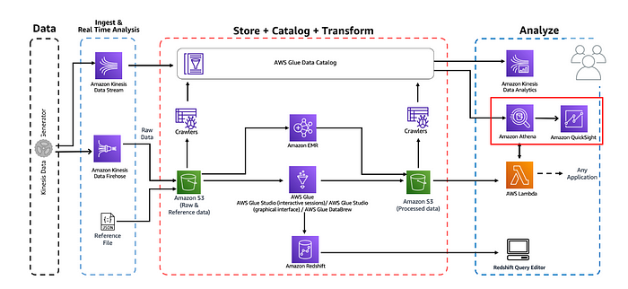

Please feel free to explore the different visualization options available in Quicksight!  
In this step we will visualize our processed data using QuickSight. Goto: Quicksight Console [Click me](https://us-east-1.quicksight.aws.amazon.com/en/start)

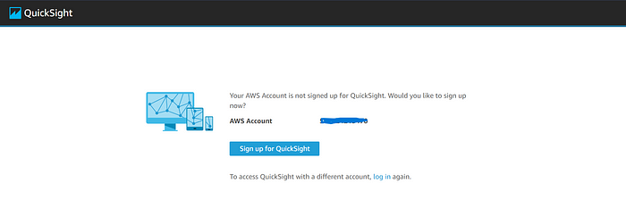

Create account. Click **Sign up for QuickSight**Ensure **Enterprise** is selected and click **Continue**QuickSight account name: yournameanalyticsworkshop  
Notification email address: you@youremail.com  
Select **Amazon Athena** — this enables QuickSight access to Amazon Athena databases.  
Select **Amazon S3.**Select **yourname-analytics-workshop-bucket.**Click **Finish.**Wait for your QuickSight account to be created.

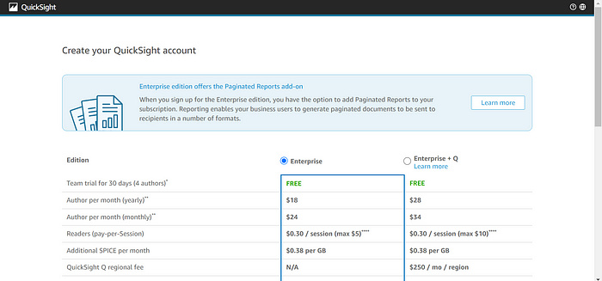

[**Adding a New Dataset**](https://catalog.us-east-1.prod.workshops.aws/workshops/44c91c21-a6a4-4b56-bd95-56bd443aa449/en-US/lab-guide/visualize#adding-a-new-dataset)Go to: [Click me](https://us-east-1.quicksight.aws.amazon.com/sn/start/data-sets). On top right, click **New Dataset.**Click **Athena.**New Athena data source.  
Data source name: analyticsworkshop

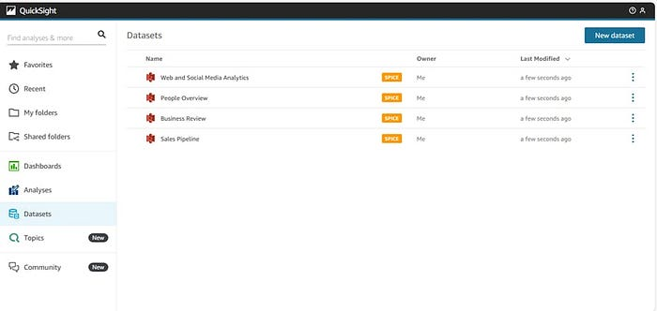

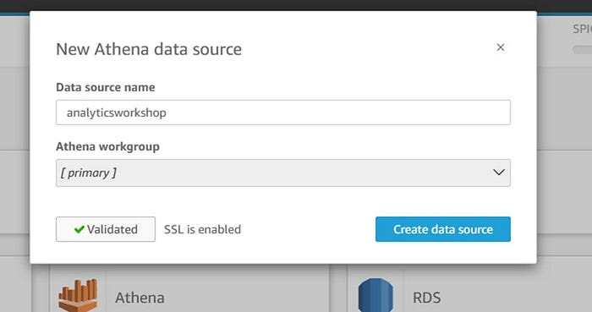

Click **Validate connection.**This will check if your QuickSight can access Athena  
Click **Create data source.**Choose your table:  
Database: contain sets of tables — select **analyticsworkshopdb**Tables: contain the data you can visualize — select **processed\_data**Click **Select.**Finish data set creation:  
Select **Directly query your data.**Click **Visualize.**

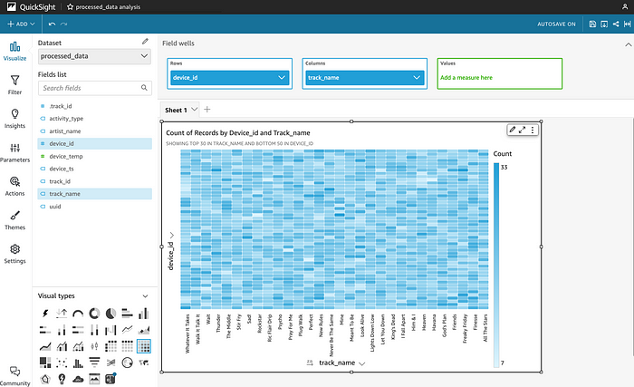

**XXXXXXXXXXXXXXXXXXXXXX**

**Task 6👉: Serve with Lambda**

In this module we are going to create a Lambda Function with a very specific use case example. The lambda function we are going to write will host the code for Athena to query and fetch Top 5 Popular Songs by Hits from processed data in S3.

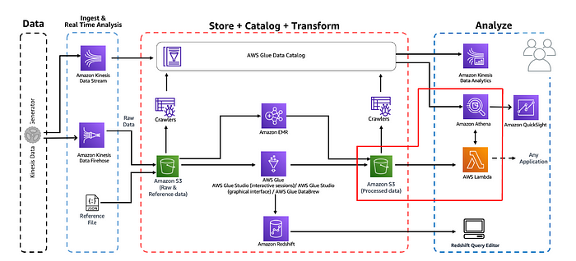

a) C[reating a Lambda Function](https://catalog.us-east-1.prod.workshops.aws/workshops/44c91c21-a6a4-4b56-bd95-56bd443aa449/en-US/lab-guide/lambda#creating-a-lambda-function)  
Go to: Lambda Console [Click me](https://console.aws.amazon.com/lambda/home?region=us-east-1). Click **Create function.**Select **Author from scratch.**Under **Basic Information**:

* Give Function name as Analyticsworkshop\_top5Songs
* Select Runtime as **Python 3.8**
* Expand **Choose or create an execution role** under Permissions, make sure **Create a new role with basic Lambda permissions** is selected. Click **Create Function**

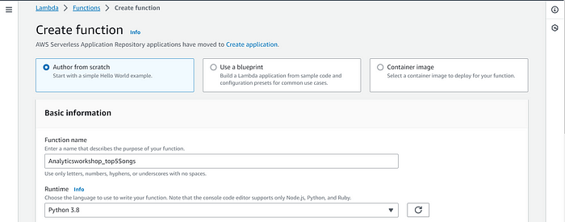

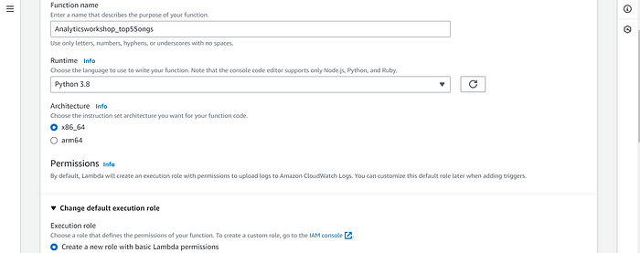

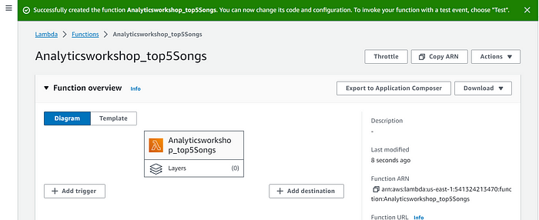

[Function Code](https://catalog.us-east-1.prod.workshops.aws/workshops/44c91c21-a6a4-4b56-bd95-56bd443aa449/en-US/lab-guide/lambda#function-code)

Scroll down to Function Code section and replace existing code under in **lambda\_function.py** with the python code below:

import boto3  
import time  
import os  
  
# Environment Variables  
DATABASE = os.environ['DATABASE']  
TABLE = os.environ['TABLE']  
# Top X Constant  
TOPX = 5  
# S3 Constant  
S3\_OUTPUT = f's3://{os.environ["BUCKET\_NAME"]}/query\_results/'  
# Number of Retries  
RETRY\_COUNT = 10  
  
def lambda\_handler(event, context):  
 client = boto3.client('athena')  
 # query variable with two environment variables and a constant  
 query = f"""  
 SELECT track\_name as \"Track Name\",   
 artist\_name as \"Artist Name\",  
 count(1) as \"Hits\"   
 FROM {DATABASE}.{TABLE}   
 GROUP BY 1,2   
 ORDER BY 3 DESC  
 LIMIT {TOPX};  
 """  
 response = client.start\_query\_execution(  
 QueryString=query,  
 QueryExecutionContext={ 'Database': DATABASE },  
 ResultConfiguration={'OutputLocation': S3\_OUTPUT}  
 )  
 query\_execution\_id = response['QueryExecutionId']  
 # Get Execution Status  
 for i in range(0, RETRY\_COUNT):  
 # Get Query Execution  
 query\_status = client.get\_query\_execution(  
 QueryExecutionId=query\_execution\_id  
 )  
 exec\_status = query\_status['QueryExecution']['Status']['State']  
 if exec\_status == 'SUCCEEDED':  
 print(f'Status: {exec\_status}')  
 break  
 elif exec\_status == 'FAILED':  
 raise Exception(f'STATUS: {exec\_status}')  
 else:  
 print(f'STATUS: {exec\_status}')  
 time.sleep(i)  
 else:  
 client.stop\_query\_execution(QueryExecutionId=query\_execution\_id)  
 raise Exception('TIME OVER')  
 # Get Query Results  
 result = client.get\_query\_results(QueryExecutionId=query\_execution\_id)  
 print(result['ResultSet']['Rows'])  
 # Function can return results to your application or service  
 # return result['ResultSet']['Rows']

[Environment Variables](https://catalog.us-east-1.prod.workshops.aws/workshops/44c91c21-a6a4-4b56-bd95-56bd443aa449/en-US/lab-guide/lambda#environment-variables)

Environment variables for Lambda functions enable you to dynamically pass settings to your function code and libraries, without making changes to your code. Read more about Lambda Environment Variables here — <https://docs.aws.amazon.com/lambda/latest/dg/env_variables.html>Scroll down to **Environment variables** section and add below three Environment variables.

* Key: DATABASE, Value: analyticsworkshopdb
* Key: TABLE, Value: processed\_data
* Key: BUCKET\_NAME, Value: yourname-analytics-workshop-bucket
* Leave the **Memory (MB)** as default which is 128 MB
* Change **Timeout** to 10 seconds.
* Optionally add Tags, e.g.: **workshop**: **AnalyticsOnAWS**
* Click **Save**

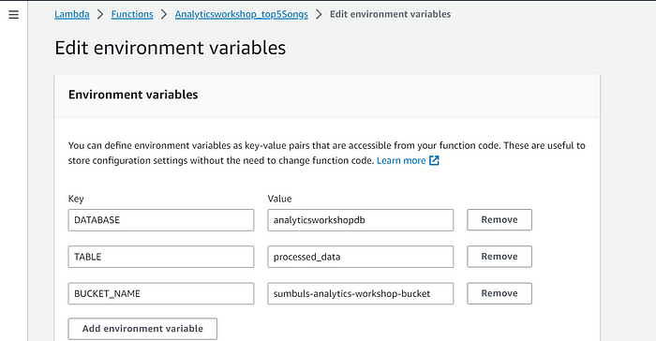

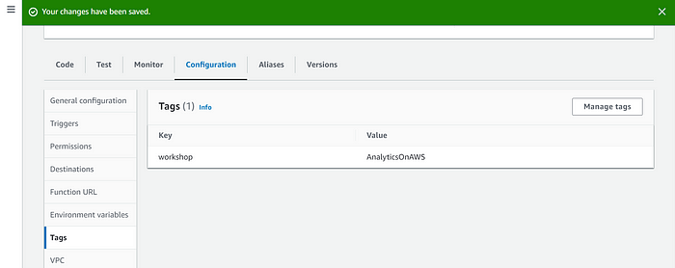

[Execution Role](https://catalog.us-east-1.prod.workshops.aws/workshops/44c91c21-a6a4-4b56-bd95-56bd443aa449/en-US/lab-guide/lambda#execution-role)  
Select the **Permissions** Tab at the top: Click the Role Name link under **Execution Role** to open the IAM Console in a new tab. Click **Add permissions** and click **Attach policies**

Add the following two policies (search in filter box, check and hit Attach policy):AmazonS3FullAccess  
AmazonAthenaFullAccess  
Once these policies are attached to the role, close this tab.

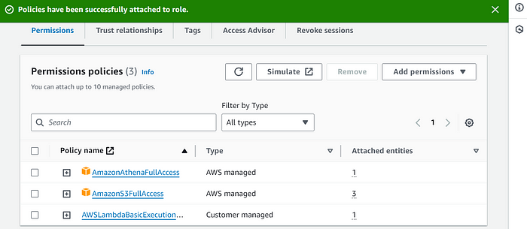

[Configuring The Test Event](https://catalog.us-east-1.prod.workshops.aws/workshops/44c91c21-a6a4-4b56-bd95-56bd443aa449/en-US/lab-guide/lambda#configuring-the-test-event)  
Our function is now ready to be tested. Deploy the function first by clicking on **Deploy** under the Function code section. Next, let’s configure a dummy test event to see execution results of our newly created lambda function.

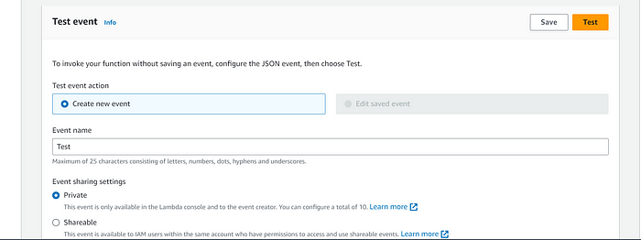

Click **Test** on right top hand corner of the lambda console. A new window will pop up for us to configure test event.  
**Create new test event** is selected by default.  
Event name: **Test**Template: **Hello World.**Leave everything as is. Click **Save.**Click **Test** again

You should be able to see the output in json format under **Execution Result** section.

[Verification through Athena](https://catalog.us-east-1.prod.workshops.aws/workshops/44c91c21-a6a4-4b56-bd95-56bd443aa449/en-US/lab-guide/lambda#verification-through-athena)  
Let’s verify the results through Athena. Goto: Athena Console [Click me](https://console.aws.amazon.com/athena/home?region=us-east-1#query).  
On the left panel, select **analyticsworkshopdb** from the dropdown.  
Run the following query:

SELECT track\_name as "Track Name",:  
 artist\_name as "Artist Name",  
 count(1) as "Hits"   
FROM analyticsworkshopdb.processed\_data   
GROUP BY 1,2   
ORDER BY 3 DESC   
LIMIT 5;

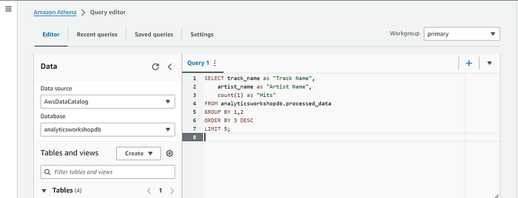

Compare the results of this query with the results of **lambda** function; they should be identical.

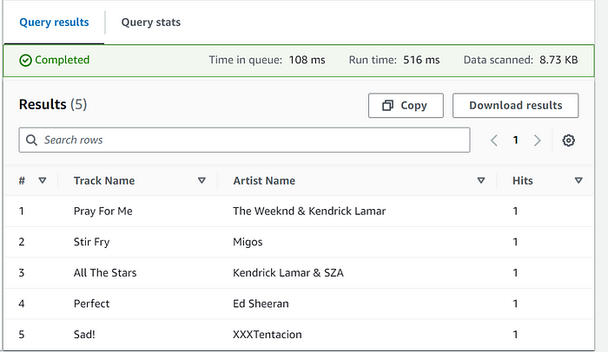

You have now created a lambda function from scratch and tested it.

**XXXXXXXXXXXXXXXX**

**Task 7 👉: Clean up**

Failing to clean up all the resources will result in incurring continued AWS usage charges. Make sure you delete all resources created as part of this lab by following all the steps below.  
[Resources to delete](https://catalog.us-east-1.prod.workshops.aws/workshops/44c91c21-a6a4-4b56-bd95-56bd443aa449/en-US/lab-guide/cleanup#resources-to-delete)

* Kinesis Firehose Delivery Stream. Go to: Kinesis Console [Click me](https://console.aws.amazon.com/firehose/home?region=us-east-1#/). Delete Firehose: **analytics-workshop-stream**
* Kinesis Data Stream. Go to: Kinesis Console [Click me](https://console.aws.amazon.com/kinesis/home?region=us-east-1#/). Delete Data Stream: **analytics-workshop-data-stream**
* Kinesis Data Analytics Studio Notebook. Go to: Kinesis Console [Click me](https://console.aws.amazon.com/kinesisanalytics/home?region=us-east-1#/). Delete Notebook: **AnalyticsWorkshop-KDANotebook**
* Lambda. Goto: Lambda Console [Click me](https://console.aws.amazon.com/lambda/home?region=us-east-1). Navigate to list of functions and select **Analyticsworkshop\_top5Songs**. Under **Actions** drop down menu, select **Delete**.
* **Glue Database.**Go to: Glue Console [Click me](https://console.aws.amazon.com/glue/home?region=us-east-1#catalog:tab=databases). Delete Database: **analyticsworkshopdb**
* **Glue Crawler.**Go to: Glue Crawlers [Click me](https://console.aws.amazon.com/glue/home?region=us-east-1#catalog:tab=crawlers) Delete Crawler: **AnalyticsworkshopCrawler**
* **Glue Studio Job**. GoTo: <https://us-east-1.console.aws.amazon.com/gluestudio/home?region=us-east-1#/jobs> Check **AnalyticsOnAWS-GlueStudio**Check **AnalyticsOnAWS-GlueIS**
* Delete **IAM Role.**Go to: IAM Console [Click me](https://console.aws.amazon.com/iam/home?region=us-east-1#/roles) Search for following roles and delete:  
  **Analyticsworkshop-GlueISRole  
  Analyticsworkshop\_RedshiftRole  
  AnalyticsworkshopKinesisAnalyticsRole  
  Analyticsworkshop\_top5Songs-role-**
* Delete **IAM Policy**Go to: IAM Console [Click me](https://us-east-1.console.aws.amazon.com/iamv2/home?region=us-east-1#/policies) Search for following policies and delete: **AWSGlueInteractiveSessionPassRolePolicy**
* Delete **S3 bucket**Go to: S3 Console [Click me](https://s3.console.aws.amazon.com/s3/home?region=us-east-1) Delete Bucket: **yourname-analytics-workshop-bucket.**You may need to first **Empty** the bucket as prompted. Once emptied, proceed to **Delete** the bucket
* Delete the **Cognito CloudFormation Stack.**Go to: CloudFormation [Click me](https://us-west-2.console.aws.amazon.com/cloudformation/home?region=us-east-1#/stacks/) Click: **Kinesis-Data-Generator-Cognito-User**Click: **Actions** > **DeleteStack.**On confirmation screen:Click **Delete**
* Close **QuickSight**account. Go to: Quicksight Console [Click me](https://us-east-1.quicksight.aws.amazon.com/en/admin#permissions) Click: **Unsubscribe**
* **Cognito Userpool.**Go to: Cognito Console [Click me](https://us-west-2.console.aws.amazon.com/cognito/users/) Click **Kinesis Data-Generator Users.**Click **Delete Pool**

That’s it! Hope you found the workshop useful!

## Conclusion

* We designed a serverless data lake architecture
* Build a data processing pipeline and Data Lake using Amazon S3 for storing data.
* Use Amazon Kinesis for real-time streaming data
* Use Amazon Kinesis Data Analytics for real-time data analysis
* Use AWS Glue to automatically catalog datasets
* Did Data Transformation
* Ran interactive ETL scripts in a Jupyter notebook on AWS Glue Studio using AWS Glue interactive sessions
* Used Glue Studio to run, and monitor ETL jobs in AWS Glue.
* Query data using Amazon Athena & visualize it using Amazon QuickSight.

**Thanks,  
Happy learning & sharing 😊  
Rohit Manral**

**References:**

* [**https://000072.awsstudygroup.com/1-introduce/**](https://000072.awsstudygroup.com/1-introduce/)
* [**https://catalog.us-east-1.prod.workshops.aws/workshops/44c91c21-a6a4-4b56-bd95-56bd443aa449/en-US/lab-guide**](https://catalog.us-east-1.prod.workshops.aws/workshops/44c91c21-a6a4-4b56-bd95-56bd443aa449/en-US/lab-guide)
* [**Medium**](https://medium.com/@sumbul.first/analytics-on-aws-workshop-c99cb0345b0e#id_token=eyJhbGciOiJSUzI1NiIsImtpZCI6IjQ1NmI1MmM4MWUzNmZlYWQyNTkyMzFhNjk0N2UwNDBlMDNlYTEyNjIiLCJ0eXAiOiJKV1QifQ..RvQtyh-b2Lj5wBtlX4Mud4OvQjIBTKUiyYSmcY_kV_Ae0VkdJLdYNSehCM4wQF3NwuZKkDDDRsgnVCbwbZQUWNzC6wU7LJfbcG-maJ0Pylj7OTfnfjzAnuJbdL36NtXqRvSWFmqejnCBgHzrOrGgYpoUrwPPnjGMm-tBuy14bbrszsJo317qt1wb3r1DBobhNfMsZOXoRD2-2Xwvk272lAZoqr7Epo2pdmNkrXI7uEy67k37_IVpOnp38dbB8Z1qjKXuqKszdmXH8rr-U65YViRxL7kjDrBSDmXQmqRWsW2tz9NUw9Sru-DjAR6l5_gDCS-mPqtwRok_S6vUqxM39w)